HTML-CSS PRACTICE 01

1. Let’s complete this table

(resource: table-basic.jpg)

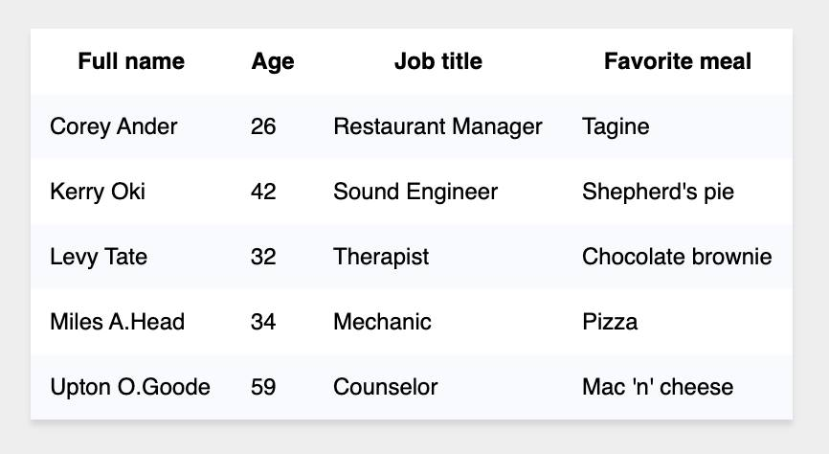

1. Let’s complete this table

Resource: table-form.jpg

